department of mechanical
engineering

SOLAR dryer

ABSTRACT

Different commodities are dried locally using different methods including natural drying in open area, solar drying. Different solar dryer designs can be found in various parts of india and a suitable design can be selected for the prototype depending on the type of drying contents, climatic condition, etc.
Open air drying was reported as most common method of drying agro-commodities. The farmers were not happy with with uncontrolled open air method and desired to design a simple and easy to use low cost dryer suitable for drying any agro commodities in a clear or /rainy day.
The purpose of this project was to study, design, fabricate and test a solar cabinet type of dryer for drying mango. Main emphasis was givenin designing a simple dryer to be made from locally available materials and different products or materials are dried like cereals,legumes, condiments, fruites, vegetables, meat and fish mostly in open air or under shade. A prototype dryer was designed for 1kg of mango slices to be dried by means of direct solar heat in conjunction with an auxiliary heater. Mango pulp is perfectly suited for conversion to juices, nectars, jams, bakery fillings, fruit meals to children, flavours for food industry, to make ice-cream& yog hurt. Processed mangoes enable exporters to serve their market even during off season period for fresh mangoes.
Having gained the confidence on the dryer performance, detailed tests were conducted to study the effects of drying modes. From performance and graphs it is seen that the percentage moisture removal desired at the design stage was achieved.

INDEX

Particulars Page no

Certificate………………………………………………………….3

Acknowledgement……………………………………………….4

Abstreact…………………………………………………………..5

List of Table……………………………………………………….9

List of Fifure……………………………………………………...10

1.Introduction………………………………………………..11

1.1 Solar Energy…………………………………………...14

1.2 Objective……………………………………………….16

2.Literature Review ………………………………………..18

2.1 Tray Stacking and efficiency………………………….19

2.2 Miscellaneous Drying Activities………………………20

2.3 Use of auxiliary components………………………. ...23

3.Design and construction of

Solar Dryer for mango slices……………………………..24

3.1 Design of Features of the Dryer……………………………..24

3.2 Design consideration………………………………………….25

3.3 Design procedure………………………………………..……25

3.4 Construction of prototype Dryer………………………….33

4.Concept of Drying with the

Sun’s warmth…………………………………….36

4.1 Drying fruts & Vegetables………………………..…………..37

4.2 Forced Drying using warm air Circulation…………………..38

4.3 Principles of the flat Plate collector with cover……………..39

4.4 Basic Technical details of the Dryer……………………… ..41

5.Types of Soloar Dryer………………………………………….41

5.1 Basic types and Application………………………………….41

5.2 Advantages and DisAdvantages of various design………...43

5.3 Solar Energy Storage………………………………………....45

5.4 Practical tips…………………………………………………....45

5.5 Different types of Available Dryer……………………………46

5.6 Application of Solar Dryer …………………………………....51

6. References……………………………………………..……….55

LIST OF TABLES

Table | Particulars | PAGE
3.1 | Design of Conditions & Assumptions | 31
3.2 | Value of Design Parameters | 32
4.1 | Drying characteristics of Some Products | 38

LIST OF FIGURE

Fig | Particulars | PAGE
1.1 | Annual mean globle irradiance on earth | 13
3.4 | Prototype Solar Dryer Sketches | 33
3.5.2 | Modal of solar Dryer | 34
4.3 | Simple Solar Dryer | 40
5.1 | Solar Dryer Directly employed | 42
5.2 | Solar Dryer Indirectly employed | 43
5.5.1 | Multi Rake Solar Dryer | 46
5.5.2 | Forced Circulation Solar Dryer | 47
5.5.3 | Solar Tunnel Dryer | 49
5.5.4 | Step Type Solar Cocoon Stifler | 50

1. INTRODUCTION

- Drying has been used to preserve food throughout the world since prehistoric times. When people learned that dried foods left out in the sun remain wholesome for long periods. The dried foods industry has greatly expanded after World War II but remained restricted to dried foods, including milk, soup, eggs fruits, yeast some meats and instant coffee etc. several mechanical drying units were built on experimental basis and a few commercial units were in operation primarily for dehydration of fruits, vegetables, and hay and seed corn. Much of the research in agriculture product up to 1955 was concerned mainly with field result. Since 1955 considerable research has dealt with theory and principles of drying in the design of farm level of commercial driers.

- Drying in one of the oldest user of solar energy. The practice has been cheaply and successfully employed all over the world for thousands of years. The basics philosophy of drying foods is to remove water for prevention of micro organisms to grow and limit food enzymatic activity. It reduces an item to roughly 50% of its original volume and 20% of its original weight through gradual elimination of water. Three basic methods of drying are used today (i) sun drying, a traditional method in which foods dry naturally in the sun, (ii) hot air drying in which foods are exposed to a blast of hot air and (iii) freeze drying in which frozen foods are placed in a vacuum chamber to draw out the water. Removing the water preserves foods because micro

organisms need water to grow and food enzymes cannot work without a watery environment.

- Historical records indicate that solar heat has been widely used to dry cereals, vegetables, fruits, fish, meat and other agro-commodities. Solar radiation is very widely used in developing countries as direct source of energy by which to dry dehydrate food of many kinds in many countries because, drying by use of fossil fuel is uneconomical.

- Drying of foods is carried out primally to ensure stability of the product quality for a given storage period or to ensure product availability in off-season. In such drying, the product is spread thinly over the ground directly exposed to solar radiation. Solar heat vaporized the water in the product and ambient air with allow relative allow relative humidity carry this moisture to the atmosphere. No doubt, the method is cheap but there are problems associated with sun drying which often result in quality of dried commodities. For example no control over drying process, possible contamination of the product by dirt, dust storms, rains, rodents, animals, infestation by insects and moulds, and possible contamination from environmental pollution. Improvements could possibly be brought about in the traditional sun drying mats and drying trays placed over the ground.
- The best way to ensure better product quality and chances of probable contamination is to dry the product in chamber type enclosed dryers either directly or indirectly. The enclosed chamber with a transparent cover receives direct solar heat and act as a green
house. Thus the heat of the sun remains trapped in the enclose thereby enhancing the temperature of the chamber. As a result drying process quick water evaporation from the product compared to direct sun drying.
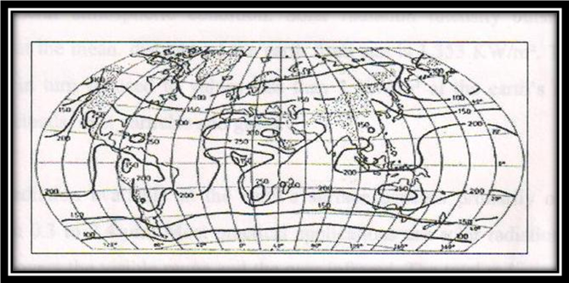

Figer 1.1 annual mean global irradiance on a horizontal plane at the surfaceof earth W/m averaged over 24 hours (Source: Budyko, 1958)

In most of the developing countries and particularly in India the solar energy is abundant , averaging 15-22 Mj/m² day , the people and the governments are very much inclined to harness the benefits of rich source of energy gifted by the almighty. Moreover, solar radiation is inexhaustible, non-polluting , and renewable and is economically feasible to be used by the rural masses particularly for drying agro-commodities. Solar radiation is receiving a considerable due to its limitless treasure available year round. Solar energy as collection near the earth’s surface is essentially a low temperature heat source. This characteristic may limit its use in high temperature drying but may make it ideally suited for the seasonal and low temperature drying various agricultural commodities.
  - SOLAR ENERGY

Recent work on solar drying has been devoted in two directions. There has been work on direct drying where in the material is exposed to direct solar heat and the product moisture is evaporated to the atmosphere to the other method drying is indirectly accomplished by the use of some type of collector, which furnishes hot air to a separate drying unit . Since solar heat is not a constant source of heat due to weather conditions. Systems that are more effective are possible in some cases if a supplemental oil/gas or electric heater is used when the weather is cloudy.

The magnitude of available radiation depends on the location, time of the year, time of the day and general atmospheric condition. Solar radiation intensity outside the earth’s atmosphere at the mean. Distance of the earth from sun is 1,353KM/ m2 . This amount of radiation is in turn reduced to values less than 1 KW/m2 at the earth’s surface by the presence of clouds, dust particles and gases.

The solar radiation available at the earth’s surface consists primarily of wavelengths ranging from 0.3 to 2.4um. Most practical applications use solar radiation 0.38 and 2.0 um, which covers the visible range and the near infrared. The total radiation incident on a horizontal surface is called global radiation or insulation. It includes the direct beam radiation, the diffuse radiation and the reflected radiation. The directed radiation is received from the sun in a linear path. The diffuse radiation however is directed from all over the sky. It is the radiation that is scattered by gases, particle etc in the air. The defuse component of radiation may vary from 10% to 100% of the global radiation. The reflected radiation originates from surfaces such as a wall of buildings, the ground and other equipment.

The methods of utilizing solar energy for drying to date have largely been based on open air-drying. However to better utilize this abundant source of energy effectively. Systems need to be developed based on specific needs. Crop dryers that can be used active dryers and passive dryers. Active dryers use an external device operated for example a fan to circulate the

air, but passive dryers do not. Although a passive system tends to be more realistic for application in developing countries because of the relatively low initial capital and operating costs, it is possible to use active system for relatively large-scale applications. There are various needs in which solar energy can be used for drying.

The open air-drying method use solar insulation, wind velocities, ambient air temperatures and relative humidity of the air to reduce the moisture content of crops. The crop is generally spread on clean ground in a thin layer. The mechanism by which the incident solar radiation. The solar radiation heats the ground and the surrounding air. Heat is transferred to the crop by conduction from the ground, by conduction and convention form the air close to the crop and by radiation from the sun. The moisture at or near the surface of the crop is thus heated
And is vaporized, which causes movement of moisture to the surface. The heat transferred to the croup may also be transmitted to the inner core by conduction, which will in turn liberate further vapour. Thus the rate of drying depends upon the available radiation and ground temperature. Because there is little or no vertical circulation of air through the croup, they have to be spread thinly, which required large land area.

Another method is to use trays slacked one above the other with their base of wire mesh. This process increases the drying rate and reduces the space needed for the crop spreading. Direct drying use dryers that consist of an enclosure with a transparent cover. The crops are placed on trays in the enclosure and elevated temperatures cause evaporation of water from crops. The moist laden air through dryer. The design of direct dryers is such that the croup is directly beneath the transparent top cover that is sloped at the appropriate angle to collect maximum solar radiation. The recommended value of this angle is α = latitude + 15۬۬۬ . indirect dryers however , use heated air in a solar air collector to dry out commodities without direct contact of solar energy with commodities. The heated air could be circulated using a fan or just natural convection.
  - OBJECTIVES

- to design and fabricate a suitable prototype for drying common agro-commodities usually dried traditionally in open air
- to evaluate the performance of the prototype using some common agro-commodities with different loads and drying modes.

Following are the some of the selected research studies mainly on vegetable and fruits drying where the post harvest losses are almost half of the total production which otherwise could be minimized if appropriate drying process were applied to preserve the commodities for off season use, and also to fetch good return for the farmers.

1.3 MATERIAL THICKNESS & DRYING

Moy et designed three type of dryers. Direct absorption solar dryer with reflector and combined mode solar dryers models. The second group of dryers had a collector attached to the main drying units.

The experimental solar drying of taro roots in slice and shredded forms indicated that the direct absorption dryer with plastic mirrors as reflectors and two mixed mode solar dryers were reasonably efficient in drying taro into stable forms of storage. With taro slices at loading density at 7.3 Kg/m³ , the direct dryer with reflector was very efficient , the mixed mode dryer and the direct cage dryer were equally efficient, but slightly less than the direct dryer with reflectors, the indirect mode of solar drying was least efficient.

While preparing the taro roots into shredded from resulted in larger surface-to-volume ratio and could be useful for making flour after the shred were nit necessarily effective for solar drying because the pieces tended to clump together thereby impending air passage through the shreds.

The quality of dried product was found was found acceptable to consumers and nutritionally satisfactory. The storage of dried product for 32 weeks at room temperature showed no adverse effect on quality or change in chemical composition. The dried product had a moisture content of 10-13%

Drying experiments over two years showed that if the drying rate due to high air velocity, was too great the product tended to dry mainly from the surface layers and after being removed from the dryer, the surface become monist again.

Be at al conducted experiments on drying of onions in an indirect solar dryer using forced convection. Properties tested include taste colour and general appearance of the dried onions. The maximum drying temperature was 50 to 55۬ C. final moisture content of the product was about 5%.

The collector and drying chamber were made of A-5 aluminum. The collecting surface was 2.32 x 1m with a cover glass thickness of 3 mm and insulation (6 cm of glass wool) on the sides and bottom of the collector. The drying chamber of three trays 15 cm apart each. The trays were made from 1 x 1 cm wire mesh to allow easy flow of air. Measurement were taken every six minutes on temperature of air entering and leaving the collector. The glass plates the collector plate and the air entering and drying chamber and the global radiation with the use of a Hewlett data acquisition system. The results obtained from the limited number of tests were found encouraging.

- LITERATURE REVIEW

- Excel (1979) worked vat the Asian institute of technology and built a rice dryer to be constructed by the local farmers at low cost using indigenous materials. In this dryer sunlight passed through the clear plastic sheet and warmed the air inside aided by a layer of burnt rice hunks that covered the ground below to absorb the radiation. The warm air passed through the bad off the paddy and dried it. The chimney provided a tall column of warm air that increases the flow of heat through the bad by natural convection. The air inlet when faced the wind direction increase the flow further.

- Djokoto et al developed and tested solar tunnel dryer for drying weight at international rise research institute (IRRI) Philippines. The dryer consisted of a collector and tunnel drying chambers arranged parallel to each other. A centrifugal blower with backward curved drying air through the collector.

- Tyuirn et al (1989) designed and developed a simple solar powered dryer for fruits. A layer of produce was spread in a solar heated chamber on a lattice through which air was forced. Roof ventilators regulated inside temperature and humidity within 6 days, grapes could be dried sufficiently for further processing, whereas onions were dried within 24 hours.

- Hauser et al (1993) designed, fabricated and tested a tunnel type solar dryer for fruit and vegetables in morocco. The installation was used for drying “canino”
Apricots, which were first cut in half and de-stoned, then immersed for 10 minutes In solution of 6% Na2S2So5 to preserve their colour and guarantee their storage life. The apricot halves were then arranged on the dryer grill in a single layer with the internal flesh uppermost at 750-1000- halves per m²

- Once the dryer was closed the fans were switched on. The maximum drying temperature was selected 65 ۬C to avoid significant quality losses. The performance of the dryer was examined and it was found that 60 kg of dry apricots could be obtained forma harvest of 3000 kg.

- Sharma et al (1994) carried out an experimental investigation on three type of solar dryers (2 natural and forced convection) for fruit and vegetable drying during the summer in southern Italy. Mushrooms, green chilies and tomatoes were used in the experiment and weight at 2 hours intervals during drying. Drying as much faster using the in directed forced convection dryer than with the cabinet or multi-stacked natural convection dryer particularly on cloudy days. There was no significated that the cabinet type natural convection dryer is suitable for drying a small quality a small quality of the fruit or vegetables on a household scale, the integrated solar collector-cum-drying system is suitable for drying a limited crop volume on frames, and the in directed multi shelf forced convection dryer is suitable for industrial use.

- Because et al (1977) described the design development optimum working condition and economic consideration of a solar energy with forced ventilation developed for use in sahelian countries for drying for product (such as meat, fish, and fruit)

  - TRY STACKING AND DRYING EFFICIENCY

Carpio (1981) while reviewing literature on drying of fish pointed out that traditional sun drying in the Philippines is associated with several problems including losses through spoilage and uneven drying, fly infestation and improper handling and storage facilities. Because sun drying is dependent upon the total surface area being exposed to sunlight , a because sun drying is dependent upon the total surface are being exposed to sunlight, a large drying area was required, but most processor had limited land resources and could only dry a fraction of the catch during seasonal gluts. Therefore the author emphasized the need to develop controlled procedure and appropriate equipment to ensure that the maximum yield of dried fish with satisfactory storage life could be produced. He further recommended the use of axial flow fans to deliver large volumes of hot air across the product at zero static pressure based on the past on the research.

Kamilov and nazarov (1990) developed a radiation convection solar energy unit which consisted of an air heater and accumulator (filled with pebbles) and a drying chamber. The drying chamber was wooden cabinet with trays inside, arranged in 4 tiers. The temperature in the drying chamber was 55-60۠ C and air velocity 0.6-1.3 m/s. Result of tests showed that the drying time. In comparison with natural drying as 1.2-2.0 times shorter and the drying quality was better. The unit could be used in field conditions also.

Fuller et al (1994) developed and tested a solar rotary tray system for use in solar tunnel dryer. The system was designed to replace and overcome the main limitation which occurred with stacked try system. The system offered advisor even drying and easy on and off loading compared with stacked trays. The anther pointed out that trials conducted in 1989 shoed uneven exposure of the bottom trays, solar radiation attenuation was approximately 70%, 30%, 10%, and 5% respectively.

  - MISCELLANEOUS DRYING ACTIVITIES

- Gomez (1981) conducted experimental on a number of vegetables to see the effect of drying on vitamin c and carotene content. Four selected species were subjected to solar dehydration with and without photo protection. Two treatments, steams blanching and sulphating were applied and Carton relation in the resulting dried product was evaluated. A control study was conducted with ambient temperature shade dried material subjected to the same pre-treatment. Mango and papaya were similarly subjected to blanching citric acid, and sucrose pre-treatment respectively to find out the cartone and vitamin C.

- Fazal-ur-rehman (1988) developed a simple technique for producing, at village level sun-dried apples. Development of pink discoloration in apples during sun drying was adequately controlled.

- Abidov et al (1990) designed and tested a solar fruit-drying unit with a solar chamber divided into three section with heat-insulated walls. The internal walls were colour black. Convention was provided by holes and intensified by a ventilation pipe. In the period of passive radiation the outlet holes were closed.

- Battcock [1990] gave an overview of the method and problems of solar drying in developing countries. Structures for solar drying eliminated some of the problems of product quality, dust contamination, damage from sudden rainstorms, animals or birds, etc. such structures include the brace dryer for fruits and vegetable drying. Chimney dryes for rice tent dryer for fish and forced convention dryer for red pappers.

- Horibe et al (1990) studies the performance of the greenhouse in order to improve the efficiency of a solar drying system for grain drying. A black or blue vinyl sheet was out on the floor inside the greenhouse as heat-collection surface. Radiation characteristics, changes of temperature and humidity in the air inside the greenhouse, and the black vinyl sheet was most efficient for heat collection.

- Miah [1993] reviewed the present situation regarding grain-drying technology in Bangladesh. Various drying methods were discussed including sun drying and drying rooms with ceiling fans, and a recently developed batch dryer was also mentioned briefly. It was concluded that while arterial dryers were not cost-effective during sunny wither, they were found essential during prolonged period of rain.

- Nile and Rumsey[1994] formulated, developed and a model that described the sun frying of a cylindrical slab of constant section obtained from a cassava tuber. The model considered the resistance to internal migration of water as the rate-determining factor. The influence of resistance of radiation intensity, ambient drbulb temperature.

- Relative humidity, wind velocity and mass of material per unit try area [loading] on the sun drying rate of cassae chips were investigated. The factors that directly influenced the internal temperature inside the food were low, such that a simple lumped-capacity models that predicted a uniform internal food temperature inside the food were low, such that predicated a uniform internal food temperature could be used in combination with the moisture field.

- Modern variations are of dry to build special enclosed drying racks or cabinates to expose the food to a flow of dry air heated by electricity, propane or solar radiation are a modern variation. These are refinements not essential to the basic process but handy, particularly in the humid tropics or when the rainy season coincides with the harvest.

- Natural ventilation may be used in dry areas such as the American southwest or the arctic. If necessary, the drying capacity of the air can be increased by heating it, which lowers the relative humidity. While any source of heat may be used, solar energy is free and usually plentiful in season. A solar heating panel screened on both and with air intake on one end and opening to the food at the other is universally used to solar heat air. Hot dry air may be moved over food by use of natural convection or a solar chimney or a fan run on solar electricity.

- Updraft solar dryer deigns are the most frequently see cabinet from. In this design, the hot air flows upward through a solar heat collection trough the try and the bottom of cabinet underneath the food. The dry air rises through the tray and around the food, exiting through a vent at the top or near the top of the shadowed side. The theoretical basis for this design is that hot air rises and therefore when heated , the air flows naturally upward through the trays of food.

  - USE OF AUXILIARY COMPONENTS

Three major components were considered for the design of the dryer. These included
- The main drying unit called “Main dryer”
- An auxiliary collector called “Booster”
- Fossil fuel heater called “Heater / stove ” for article heating in cloudy /rainy days

Carpio (1981) and Boston et al (1992) pointed out than sun drying depended upon total surface area exposed to sunlight. Therefore, emphasis was given to load the material in the trays stacked one above the other to provide maximum surface area to let escape the moisture from the commodity through maximum surface area.

Duffie and beckhan [1974] noted that flat plat collector could be designed for applications requiring energy delivery at moderate temperature and those they do not require qriatation towards sun. agrawal [1983] pointed out that in northern hemisphere , the most favorable oriatation is that the surface facing south should be inclined at an angel to latitude + 15 ° in winer and latitude - 15 ° in summer , wheres stine and harridam [1985] suggested the most logical tilt angel for fixed flate plate collectors with a tilted surface from horizontal at an angel equal to the latitude angel.

    - USE OF AUXILIARY COMPONENTS

A chimney of was fabricated from iron sheet 1 mm thick. The shape of the chimney resembled a rectangular block with top cover of a hut shape structure 45 ° included with horizontal and properly reverted with the body of the chimney. The top cover had sufficient clearance to allow escape of moist laden air from the chimney to the open atmosphere. The entire chimney was painted black to further increase the temperature of the moist laden air in chimney for fast escape under buoyancy effect through natural convection , without the use of a fan or a blower.

    - AUXILIARY HEATER (BOOSTER)

To evaluate the effect of indirrect solar heat on drying of the agro commodities. An auxiliary heater (booster) was designed and fabricated. This was an attachment to the main drying unit through a G.I sheet duct, connection both the main dryer add the booster. The main aim to design and fabricate the auxiliary heater was to supplement the main drying unit by providing additional solar heated air indirectly to the main dryer.

- DESIGN & CONSTRUCTION OF SOLAR DRYER FOR MANGO SLICE

We have taken help of the design prepared and use in Sudan by admin omda, Mohamed okay, Mohamed ayosub Ismail. The geographical and climatic condition of India and Sudan are almost same, hence the assumption made were taken up into the calculation. Sudan and India are both situated at 20 ° latitude (center) and both are typical countries. The average ambient condition are 30 ° C air temperature 25 % R,H. in month of April with daily global solar radiation incident on horizontal surface of about 20 MJ/m² per day.

OBJECTIVE:

To designed a natural convection solar dryer to dry mango slices. Solar dryer to be constructed to dry 1 kg of mango slice. Initial moisture content of mangoes is 85% & final moisture content desired is 6%.

  - DESIGN FEATURES OF THE DRYER

The solar dryers has the shape of a home cabinet with tilted transparent top. The angle of the slope of the dryer cover is 37 ° for the latitude location it provided with air inlet and outlet holes at the front and back respectively. The outlet vent is higher level. The vents have sliding covers which control air and outflow.
The movement of air through the vents, when the dryer is placed in the path of air flow , brings about a thermo siphon effect which creates an updraft of solar heated air laden with moisture out of the drying chamber.

3.2 SOLAR DRYER DESIGN CONSIDERATIONS:

A solar dryer was design based on the procedure described by amprature (1998) for drying dates ( a cabinet type) and procedure described by Bosnia Abe (2001) for drying rough rice (natural convection a mixed-mode type )
The size of the dryer was determined based on preliminary investigation which was found to be 2.6 kg / m ² (try loading ). The sample thickness is 3 mm as recommended by Bret et al. (1996) for solar drying of mango slices.

The following points were considered in the design of the natural convection solar dryer system:
- The amount of moisture to be removed from a given quality of wet
mango /orange
- Harvesting period during which the drying is needed.
- The daily sunshine hours for the selection of the total drying time.
- The quality of air needed for drying.
- Daily solar radiation to determine energy received by the dryer per day.
- Wind speed for the calculation of air vent dimensions.

  - DESIGN PROCEDURE:

The size of the dryer was determined as a function of the drying area needed per kilogram of pulp of fruits. The drying temperature was established as a function of the maximum limit of temperature the fruits might support. From the climatic data the mean average day temperature in April is 30 ° C and RH is 25% . from the psychometric chart the humidity ratio is 0.0018kg H2O/kg dry air. From the result of preliminary experiments on the croup, the optimal drying temperature was 74 ° C and final moisture content of the mango for storage is 6% w.b.

    - DESIGN CALCULATION

TO carry out design calculation and size of the dryer, the design condition applicable to jaipur are required. The condition and summarized in Table 1 are used for the design of the mango dryer. From the condition, assumption and relationship, the values of the design parameters were calculated.
The result of calculation are summarized in table 5.2.
i-Amount of the moisture to be removed from a given quality of wet mango slice to bring the moisture content to safe storage level in a specified time.

The amount of moisture to be removed from the product, mw is kg was calculated using the following equation:
Mw=mp(Mi-Mf)/(100-Mf) ---------------------------------- (1)

Where :
-mp is the initial mass of product to be dried, kg ;
-M is the initial moisture content, % wet basis,
-Mf is the final moisture content, % wet basis.

mw = 1(0.85-0.06)/(100-0.06)
=0.79 kg of water /kg of mango.

ii – Final Or Equilibrium Relative Humidity; final relative humidity or equilibrium relative humidity was calculated using sorption isotherms equation for mango given by Hernandez et al (2000) as follows:

aw =1-exp[-exp(0.914+0.5639lnM)] ------------------------- (2)

where

aw =water activity, decimal
M =moisture content dry basis, kg water/kg dry solids
=0.85 kg water/kg dry mangoes

aw =ERH/100 ------------------------------------------- (3)

0.89729=2.610 x RH/100
RH = 34.37

iii- Quality of heat needed to evaporate the H₂O;

the quantity of heat required to evaporate the H2O would be:

Q =mw x h f g --------------------------------------------------- (4)

= 079 x 23255.74

= 18372.0346 KJ

Where :

Q = the amount of energy required for the drying process, k J
mw =mass water , kg
h f g =latent heat of evaporation, kJ/kg H2O

the amount needed is the function of temperature and moisture content of the croup. The latent heat of vaporization was calculated using equation given by Youcef- Ali et al. (2001)
as follows:

h f g =4.186 x (597 – 0.56(Tpr)) -------------------------------- (5)

=4.186 x (597 – 0.56(74))

= 232555.74 kJ/kg.
Where:

Tpr = product temperature, °C
=74 °C

Moreover , the total heat energy, E (kg) required to evaporate water was calculated as follows:

E = m’ (hf-hi)t --------------------------------------------------- (6)

=6.475(78.18-29.764) x 10

=3.1349 MJ

Where:

e =total heat energy, kj
m =mass flow rate of air, kg/hr.
hf and hi = final and enthalpy of drying and ambient air respectively, kJ/kg dry
air.
td = drying time, hrs
= 10 hrs.

The enthaphalpy (h) of moist air in J/kg dry air temperature T(°C)can be approximated as (Brooker el al.,1992);

H = 1006.9T + w [2512131.0 + 1552.4T] ………………… (7)

hi =1006.9 x 25 + 0.0018[2512131.0 + 1552.4 x 25]
=29.729kJ/kg dry air.

hf =1006.9 x 55 + 0.0014[2512131.0 + 1552.4 x 55]
=88.13 kJ/kg dry air.

iv- Average drying rate

average drying rate, mdr, was determined from the mass of moisture to be removed by solar heat and drying time by the following equation:

mdr =mw/td ------------------------------------------------------ (8)

=079/10

=0.79 kg of water / hr.

The mass OF AIR needed for drying was calculated using equation given by sodha et al. (1987) as follows:

M = mdr / [ wf –wi ] ------------------------------------------------ (9)

= 0.079 / ( 0.014 – 0.0018)

= 6.475 kg of air / hr.

Where:

Mdr = average drying rate, kg/hr

Wf & wi = find and initial humidity ratio, respectively , kg H2O / kg dry air

From the total useful heat energy required to evaporate moisture and the net radiation received by the tilted collector, the solar drying system collector area Ac, in m² can be calculated from the following equation.

Ac =E/Iή -------------------------------------------- (10)

=3.134/20 x 0.35

=0.447 m²

Length of collector = 0.9 mts
Width of collector =0.5 mts

Where :-
E is the total useful energy received by the drying air , kj;
i is the global radiation on the horizontal surface during period, kj /m² =
20 kj /m²
&
ή is the collector efficiency , 35 % (sodha et al.,1987)
volumetric airflow rate , va was obtained by dividing ma by density of air which is 1.2 kg/ m³

TABLE 3.1 DESIGN CONDITION & ASSUMPTION

Item | Condition or assumption
Location | Jaipur (latitude 22° N)
Crop | Mango
Variedty | Totapuri
Drying period | April june
Drying per betch( 2days/batch) | 1 kg of mango
Initial moisture content ( moisture content at harvest ), Mi | 85 % w.b
Final moisture content (moisture content for storage ) , Mf | 0.6 % w.b
Ambient air temperature, Tam | 30 °C (Average for April)
Ambient relative humidity, Rham | 25 % (average for April)
Maximum allowable temperature, Tmax | 74 °C
Drying time(sunshine hours) td | 10 hours (average for april)
Incident solar radiation, I | 20 MJ/m²⁻/day (average for past 30 years)
Collector efficiency, ή | 35% (Ampratwum, 1998).
Wind speed | 1.5 m/s
Thickness of sliced mango | 3 mm

TABLE 3.2 VALUES OF DESIGN PARAMETERS

PARAMETER  USED | VALUE | DATE OF EQUATION
initial humidity ratio, wi | 0.0018 KG H2O/kg dry air | Tam, RHam
Initial enthalpy, hi | 29.76 kJ/kg dry air | Tam, RHam
Equilibrium relativehumidty, RHf | 34.37% | Mf and isotherms equation (2)
Final enthalpy, Hf | 78.18 KJ/kg dry air | Wi and Tf
Final humisity ratio, wf | 0.014 kgH2O/kg dry air | RHF and hf
Mass of water to be evaporated, mw | 0.79 kg of air/hr | Equation (1)
Average drying rate, mdr | 0.079kgH2O/he | Equation (8)
Air flow rate, ma | 6.475 kg dry air.hr | Equation (9)
Volumetric airflow rate, Va | 5.396 m³/hr | Ma, air density (ρ)
Total useful energy, E | 3.1349 MJ | Equation (6)
Solar collector are, AC | 0.45 m² | Equation (11)

  - construction of prototype dryer

a natural convection solar dryer of a box – type ( cabinet was designed and constructed. The constructed dryer (cabinet –type) consisted of drying chamber and solar collector combined in one unit as shown in fig. 9.

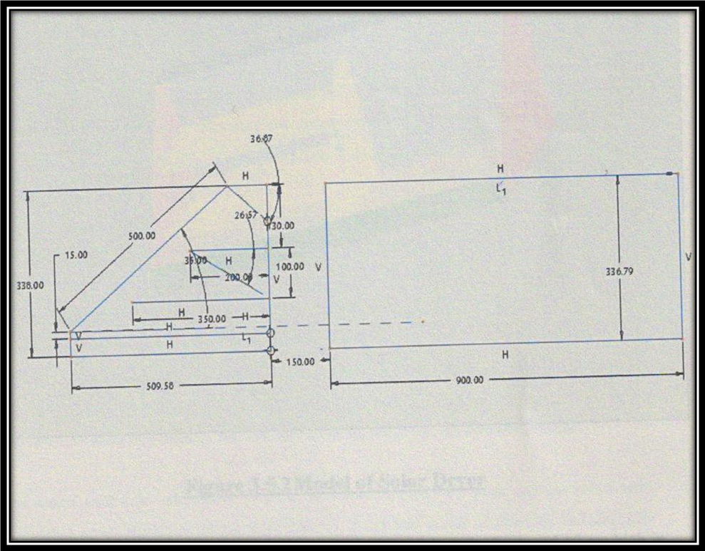

Fig 3.5 2D layout of solar dryer

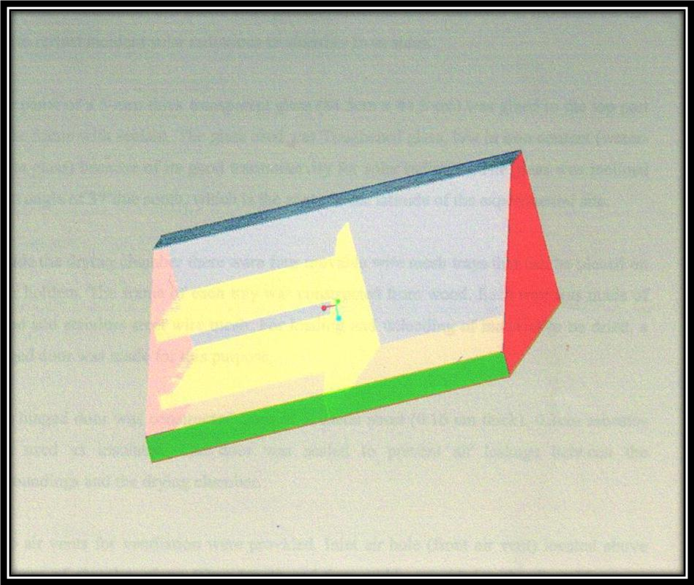

Figure 3.5.2 model of solar dryer
A simple box frame 90cm long, 51 cm wide and 34cm hight at the back and 10 cm high in front made of mild steel plates (16 guages ) 1.6mm was fabricated. Sheets of mild metal sheet 0.16cm thick were welded onto three sides and bottom of the fabricated frame. Glass wood was used as insulator with a thickness of 1 cm and placed the bottom mild metal sheet.

Try holders made of angle iron were welded in such away to hold try inside drying chamber. The lower holder was 15cm above the absorber glass wool and the upper was 15. Asbestos sheet of 0.3 cm thick were used as insulator and fitted to the three inner sides of the
frame. Aluminum foil sheets were glued to asbestos sheet and used as moisture barrier and to reflect incident solar radiation to absorber from sides.

One panel of a 5-mm thick transparent glass (84.5 cm x 44.5 cm ) was glued to the top part of the frame with sealant. The glass used was toughened glass, low in iron content (water white glass) because of its good transmissivity for solar radiation. The glass was inclined at an angle of 37° due south, which is the angle of the experimental site.

In side the drying chamber there were four movable wire mesh trays that can be placed on their hiders. The frame of each try was constructed from wood. Each tray was made of wood and stainless steel wire mesh. For loading and unloading of material to be dried, a hinged door was made for this purpose.

The hinged door was constructed from M.S. metal sheet (0.16 cm thick ) , 0.3 cm asbestos was use as insulator. The door was sealed to prevent air leakage between the surrounding and drying chamber.

Two air vents for ventialation were provided. Intel air hole (front air vent) located above the base of absorber plate; 60cm legth and 6 cm width, provided with adjustable cover that was tow level of operating; full and half opening for dryer temperature control.

The outlet vent (rear air vent); 60 cm x 6 cm was locked top edge and provided with adjustable cover for dryer temperature control. It has two levels of opening; full and half opening.

    - FOR FORCED CIRCULATION
DC brushless fan was used of following section;

Size :- 80 x 80 x 25
Voltage :- 12 V
Bearing :- sleeve
Current :- 0.12 mA
RPM :- 2500
Air flow rate :- 32CFM

An electric heater as backup with thermostat controller was used. The specification was as followed: 0.5 kw , U-tube finned type.

4.CONCEPT OF DRYING WITH SUN’S WARMATH

Imagine a closed heated space in which a fruit or damp agriculture croup has been stored two things happen;

- The crops warned by the heat from the stove of fire
- Air around the heat source is heated up – whereby it can take up a great deal of moisture – and , rising , is continually replaced.

As the crop is warmed up , including the air between the plant fibers , the water it contains quickly evaporates. Pretty soon the air within and surrounding the croup is saturated with water vapour. Fortunately the air moving alongside, warm and unsecured can take up this moisture and transport it away. A small fan will of course help this process, but it is not strictly necessary.

At a certain moment the air in the room has taken up so much moisture from the croup that the windows suddenly mist up ( though this will depend on the outside temperature ); the air against the could window has been cooled to below the ‘dew point’. In this way the water in the croup is transferred to the window panes, where it can be wiped off, or allowed to fall into a gutter which leads outsides the room.

If in this account ‘heat source’ is replaced by sun , a solar drier has effectively been described. The ‘cold window’ (which works as a condeser) is sometimes encountred in indirect drying, where the warming of air the drying of the croup are separated, if the product has been stacked too high or too together.

Solar drying is technique particulary suited the warmer parts of world since:

- There is sbundant sunlight.
- The air temparature is high and relative constant over the whole year.

A high and stable air temparature is actually just as important as the sunshine itself, since it limits loss of generated warmth. It allows a simple solar drier to maintain the temparature of the drying fruit crop the day around 40°C.

4.1 DRYING FRUITS & VEGETABLES

The temperature within the solar drier is higher than that outside it. Consequently water on and in the product evaporates. The air takes up more of this moisture until a certain equilibrium is reached. Ventilation ensures that this saturated is replaced with less saturated air, and so the product eventually dries out. Drying is intended to evaporate and dispel the free warer in product make it unviable to micro organism. This water can also be bound, by adding salts(pickling) or sugar (preserving). Both techniques can also be used after drying. Dried products attract moisture from the air, just as salt does. This moisture remains much free – to – micro organisms – than the moisture which was removed from the product; so even in condition of relavely low the product will rot.

TABLE – 4.1 DRYING CHARACTERSTICS OF SOME PRODUCTS

SR.  NO. | PRODUCT | FORM | DRYING  TEMP. (°C) | MOISTURE CONTENT(W.B) %
 |  |  |  | INITIAL | FINAL
1 | Amla | Pieces | 67 | 81.0 | 15.0
2 | Carrot | slices | 56 | 91.0 | 8.0
3 | Green chilly | pieces | 73 | 86.0 | 7.0
4 | Mango | slices | 74 | 85.0 | 6.0
5 | Mango bar | pulp | 62 | 40.0 | 14.0
6 | Potato | slices | 58 | 82.0 | 6.0
7 | Sweet mango | slices | 62 | 34.5 | 4.0
8 | Tomato | pieces | 80 | 94.0 | 5.5

The warmth in the drier actually encourages rotting in product that are not yet compliantly dried. For this reason the speed at which the drying takes place is important. The fastest drying is brought about by strong ventilation with dry air.

Under such circumstances the difference between the internal and external temperature is less important than simply getting rid of the moisture as fast as possible. At a later stage the evaporation is les abundant, and much more temperature dependent. If the ventilation is now limited, the air in the dried will be warmed up, and the drying process improved further.

These consideration apart, the quality of the original product ( its freshness and cleanliss. ) and of the drying air both exert a critical on the quality of the end product.

4.2 FORCED DRYING USING WARM CIRCULATION

Good ventilation is crucial importance. It determines on the one hand the exchange of the warmth from absorbent surface to the air next to it and on the other hand the evaporation of the water on and in the product. Stronger ventilation leads to lower average temperature but also to a more efficient overall transfer of warmth. This leads to a reduction in the relative and improved drying.

Electric fans strongly increase the transfer of warmath to the drying air. This is especially true if the product is stacked close together, impending the air circulation. It is important, therefore, to rack and shelve the product in such a way that the products in such a way that the air circulation is impeded as little as possible. Forced air circulation is only worthwhile if sufficient energy can be taken in by the drier; this supposes a large enough ( with regard to the mass to be dried) and efficient enough absorbent surface ( for example, porous material), and special glass for covering.

If this factors are not taken into account, the temperature within the drier will not be much higher than that outside it – which of coerce does not promote efficient drying, and certainly not at the last drying stage. Forced air circulation becomes economics in larger installation drying 50-10 kg per day more. In non-forced air circulation, or natural ventilation a site is chosen which makes best use of prevailing wides, the air inlet and outlet being oriented accordingly, or a chimney is added to improve the draught.

4.3 THE PRINCIPAL OF THE FLAT-PLATE COLECTOR WITH
COVER

4.3.1 PHYSICAL DISCRIPATION

The principal underlying the solar collector is that ‘visible light’ falling onto a dark objec is converted into tangible warmth. The colour of the object does not in fact need to bee black; it is rather the absorptive qualities of the material which determine the effect. A painted plate can be warmed, but so can a suitable fibros material such as charred rice chaff.

The cover is of secondary importance, but still has decisive influence on the total working efficiency; it prevent the created warmth from being blown away and also limits the warmed-up objects’ heat loss through re-rediation. Moreover it allows a controlled air stream over the warmed objects, which would not otherwise be possible.
To expolit the warmth in the heated objects or surface a mediam (water, air ) is directed alongside which takes up the warmth and takes it is needed. When air is used, it can pass under the collector, above it, or through canals embedded within it. It can be ‘ forced ‘ or a ‘ natural ‘ current.

In drying, the relative and absolute humidity are of great importance. Air can take up moisture, but only up to a limit. This limit is the absolute (=maximum) humidity, and is temparature dependent.

In practice, however, the air is very rerely fully saturated with moisture. The degree of saturation at a given temparature is called the relative humidity and express as a percentage of the absolute humidity at that temparature.

If air is passed over a moist substance it will take up moisture until it is virtually fully saturated, that is to say until absolute has been reached.

However, the capacity of the air for taking up this moisture is dependent on its temparature. The higher the remparature, the higher the absolute humidity, and the larger the uptake of moisture.

If air is warmed the amount of moisture in it remains the same, but the relative humidity falls; and the air is therefore enabled to take up more moisture from its surrondings.

If fully-saturated air is warmed and than passed over the objects to be dried, the rise in absolute humidity ( and the fail in relative humidity ) allows still more water to taken up.

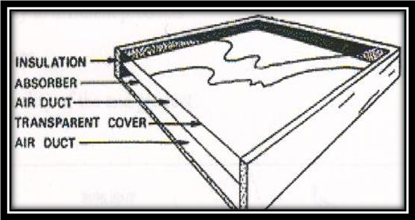
Figure 4.3 simple solar drver
4.4 BASIC TECHNICAL DETAILS OF THE DRVER

Every solar drier is constructed using the same basic units, namely:

- A transparent cover which admits sunlight and limits heats loss (glass or plastic)
- An absorbent surface, made dark in colour, which takes up sunlight and converts it to warmth then giving this can also be the product that needs drting it self.
- An insulating layer underneath.
- An air intake and an outlet, by which means the damper air can be replaced with fresh drier air.
The four elements can be modifieds if necessary, and/or othe element added, for example a fan or chimney.

- TYPES OF SOLAR DRYER

5.1 BASIC TYPE & THEIR APPLICATIONS

In choosing a certain type of dryer account must be takken of the following six criteria:

- The use of locally avalible construction materials and skills.
- The investment of the purchase price and maintance costs.
- Drying capacity, holding capacity.
- Adaptability to different products.
- Drying times
- (fall in) quality of the end product.

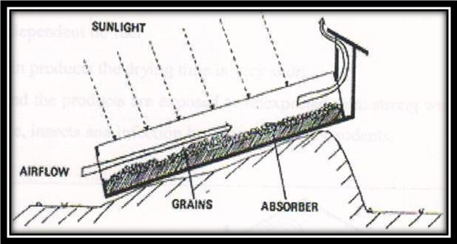

Figer 5.1 solar dryer directly employed

solar dryers can be constured out of ordinary, locally avlible materials, making them well suited for domestic manufacture.

Solar driers can be divided into two categories:

- Dryers in which the sunlight is directly emoloyed; warth absortion occurs here primarily by the product itself. These are further divisible three sorts:

- Traditional drying racks in the open air
- Covered racks ( prodecting agaist dust and insect )
- Drying boxes provided with insulation and absorptive material.

- Dryers in which the sunlight is employed indirectly, in this method , the drying air is warmed in a space other than that where the product is stacked. The products then are not exposed to direct sunlight. Various sorts of construction are possible ; this design can also be provide with powered fans in order to optimise the air circulation.

5.2ADVANTAGES & DISADVANTAGES OF VARIOUS DESIGNS

5.2 DIRECT DRYING

Tradition open-rack drying enjoys four considerable advantages.

- It demands a minimum of financial investment
- Low running costs
- It is not dependent on fuel
- For certain products the dryingtime is very short
On the order hand the product are exposed to unexpected rain, strong winds and the dust the carry, larves, insects and infection by, amongst others, redents.

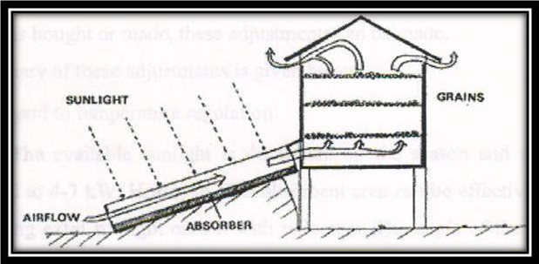

Figure 5.2 solar drver indirectly employed
Moreover, certain sessitive products can become overheated and evantually charred. Dried fruits so spoiled necessary loses its sale value.

Commercially available drivers often appear to be economically unfeasible. Specifically, not enough product can be dried fast enogh to recop the outlay. Larger (combined) installation are more cost-effective but call for sophisticated management if the input and output of product is to be held at a controlled, and high, level. They are also fitted with articial heating ( fires) and fans.

5.2.2 INDIRECT DRYING

The advantages in the indirect system are that:

- The product is exposed to less high temperatures, whereby the risk of charring is reduced
- The product is not exposed to ultraviolet radiation, which would otherwise reduced the chlorophyll and whiten the vegetables.

However, its use demands some care. Faulty stacking of the product to be dried can lead to condensation; rising hot air in the lowest layers becomes saturated, but cool so quickly as it rises that the water condense out again in the upper layers.

This problem can be overcome by:

A dryer which operate optimally is usually the result of a number of adjustment whose value is established by trial and error and simple drying tests. It is therefore important that if a solar dryer is bought or made, these adjustments can be made.
A summary of this adjustment is given below.
- With regard to temperature regulation:
- The available sunlight is dependent on the season and the location and limited to 4-7 kW. Hr/day/m. the absorbent area can be effectively by directing extra sunlight onto it with reflector. The angle of the absorber is also specified by the latitude. Take care that the collector is facing the sun and that it is out of shadow as far as possible.

- It is simple matter to insulate the drier better and thereby raise the degree of heat absorption (and air warmth uptake). The wall of a covered dried - which the sun cannot pass through – is better replaced by insulating material which lines the box and painted black.

- The heat collector of an indirect dryer can be improved by:
- Enlarging the absorptive capacity
- Reducing heat loss, by means of insulation and keeping hot air-glass contact to minimum.

In the absence of forced ventilation, the chimney-effect is crucial. The difference in height between the air intake and outlet largely determines the draught and therefore the ‘natural’ ventilation.

- A chimney will help provided that :
- It is enough; if it is too small it will obstruct the draught.
- It is warm enough.

The air must not cool – this causes a reverse airflow, a wooden chimney is suitable. A chimney less than 40 cm height will in this case suffice.

Despite the many experiment carried out in almost every tropical area, it still appears to be impossible to design the ‘ideal’ solar drier. Depending on the building materials used, the product that need drying, and the season in which the drying must take place, the ‘ideal ‘ dryer take many forms.

5.3 SOLAR ENERGY STORAGE

Excess heat generated during the hottest hours of the day can be stored by passing the air through, for example, a container full of stones. This only work in forced circulation system, as the stones cause considerable pressure loss in the airflow. Storing solar warmth in this way allows the excess heat generated by oversized collector to be used again during the night for more drying.

Such as installation makes it possible to control the air temperature in the drying room, and thus to ensure that the different drying stages work well ( for example, for sowing-seeds). In the first drying stage higher temperature are allowable because the considerable free water still in the product.

5.4 PRACTICAL TIPS

For the transparent cover, glass is the suggested material, but it is often difficult to obtain and rather expensive. Plastic offer a reasonable alternative. It is less radiation-efficient, but often enough more readily available. If plastic is stretched over the collector it will sag. Dust and rain can collect in the hollow. This can be remedied by fitting a supporting rib across the collector along its longest axis. If this is fixed slightly higher than the edges of the collector the plastic cover will slope down slight on either side of the rib. Take care that there are no air takes at the rib ands.

Dust on the cover reduces its efficiency, and should be removed as often as possible. If than collector is strongly titled, this favors the airflow and therefore promotes good heat transfer. However , the further it is titled below the sun the less sunlight it receive. For this reason the indirect dryers are often better in practice.

Watch out for excessive surrounding air humidity, for instance during misty early mornings. It is vital that the drier is only set into operation. ( by opening the air intake and outlet) after the mist has risen and the air humidity has fallan. Otherwise there is a risk that in the weak early morning sunshine product, instead of being dried, attracts condensation.

5.5 DIFFERENT TYPE OF AVALIBLE DRYER

5.5.1 MULTI RACK SOLAR DRYER:

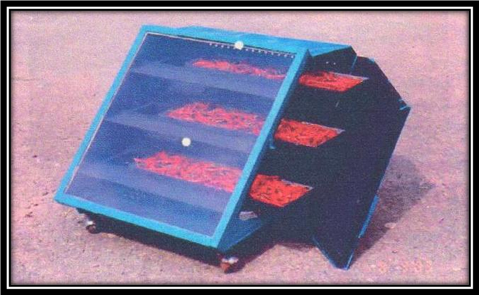

PAULUDHIANA

Function : Natural convection type device used to dry product like fruits, vegetables, spice etc. for domestic use under hygienic conditions.

Design Features: high Efficiency, uniform drying of product, option to dry products in shade, suitability for rural/remote places, drying temperature in desirable range, light weight and essay to move.

Important specifications: Aperture area – 0.36 sq m, external dimension – 620x620x350 mm, ;oaring per batch -1-3 kg (depending on product), drying time per batch -2-3 days ( depending product ), inclination of the dryer – variable – fixed 30º45 º for north & 30 º for south

Performance :- the maximum stagnation temperature achieve in the dryer in winter months in northern India was 100º c for solar insulation of 750 W/m² and ambient temperature of 30⁰c. Solar dried chilies cost 15 % lower than the cost of the unbranded product and 57% lower than the branded product available in local market. Payback period worked out to be 84 days.

Present status: commercially available at a cost of round Rs.1600/- (us $ 35) from M/s vishwa karma solar energy corporation (regd.) , pillars -144410 (Punjab) India.

5.5.2. FORCED CIRCULATION SALAR DRYER:

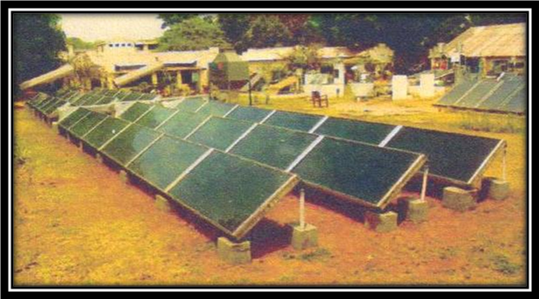
SPRERI V.V.NAGAR

FUNCTION:- used to achieved faster drying of high value products at industrial /commercial scale.

Salient feature: consist of solar air heaters, electrical blower, connecting ducts, drying chamber and control system for air temperature and flow rate. Equipped with high efficiently packed bed type and low cost unglazed type solar air heaters and electrical/biomass based heater provided bed type as thermal back up to supplemented heat requirement for operation during cloudy weather and night hours. The system can be designed for drying most of the agro-products.

Performance: efficiency of the packed bed type solar air heater was found around 40% more than commercial heater, very good quality finished product and agro-product retain their colour and flavor to a large extent.

Approximate cost:- packed bed type and unglazed type flute plate solar air heaters cost RS. 3,500(US $ 77) & Rs.2000/- (US $ 44 ) per square meter area, respectively. A 200 kg/d capacity solar of the onion flakes cost two that of the electric fired dryers. However, cost of the drying per kg product of the solar dryer is less than half that of the electrical dryer.

Present status: A few installations are under operation for drying onion flakes, tomatoes mushroom etc. the design, installation and commixing and commission of the oral dryer system can be taken up on consultancy basis.

5.5.3 solar tunnel dryer for agro industrial application:-

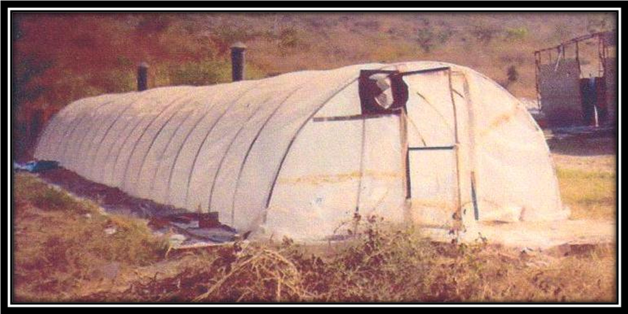
MPUA & T Udaipur centre

Function: Natural walk –in type dryer useful for bulk drying of agriculture & industrial products at moderate air temperature.

Design feature: consists of a hemi-cylindrical metallic frame (3.5m x 21.0m)

covered with UV stabilized transparent polythene sheet of 200 micron thickness, two chimney on the top and an exhaust fan on one side, product spread on trays put on trolleys moved inside dryer.
Performance: the average temperature inside the tunnel found 15 – 18 ⁰ higher than the ambient temperature. The moisture content of 1.5 ton basic calcium phosphate is reduced to around 15 % from an initial value of 35-40% in 2-3 solar days depending upon the solar insulation.

Approximate cost : Approximately cost of material and labor around RS 50,000 (US $ 1099 ) and payback period is around 80-100 working days. Costs of drying is reduced by around Rs 800 (US $ 17.6) per ton in solar tunnel dryer compared to the diesel fired mechanical dryer

5.5.4 STEP TYPE SOLAR COCOON STIFLER:

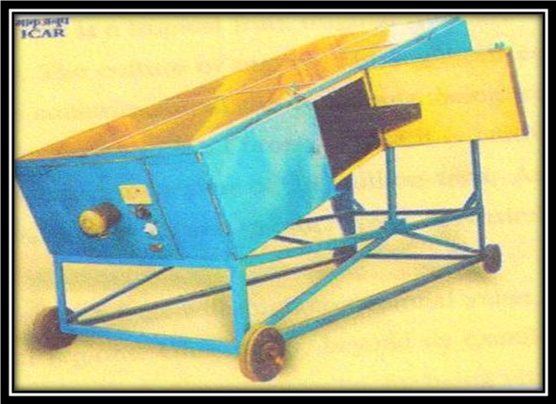

Function:- A multi-rack natural convection solaqqr dryer has been modified for cocoon stifling ( killing papa inside the cocoon).

Design features:- batch type stiffer, portable, eases loading & unloading of cocoons, glass wool insulation, double glass glazing back-up of 2 kW rating with thermostat, collector are of 2m² and loading capacity of 10 kg cocoons per batch.

Performance:- the peak stagnation temperature was found to be around 95⁰C in winter and 125⁰C in summer in central India. Average capacity in a silk reeling center was found to be 20-60 kg / day depending upon season. The remittal of solar stifled and electric oven stifled cocoons was almost same.

Cost: the stiffer costs around Rs. 15,000/-(US $ 330). Solar stifling of cocoons costs around 35% lower than stifling by electric c oven method.

5.6 APPLICATION OF SOLAR DRYER & DRYED MANGOES

the mango ( mangifera indicia )is a tropical fruit, original from the south of asia, and ot is avlible worlwide today. The calture of mango, although still concentrated asia, was become enlarged for some countries, in all the continets, being important in africa and americas and with lesser presence in the Europ, where it is caltivated in small scale in spain. From the annual world production of 18 milion tones, asia accounts for 75% , americas 14%, africa 10% and 1 % remain in other areas, as austalia and europe.

The mango is distinguished as fruits with high commercial value in many regions of the world, mainly the tropical regions. Universally, beyond its exellent qualities of flavour and aroma, they have its recognized alimentary value, for being vitamin A and C source.

The food dehydration is one of the common used food conservation processes for increase of shelf life, reduation of costs of packing, transport and storage and modification of sensorial attributes (Queiroz,2003).

5.6.1 DRYING OF FRUITS & VEGETABLES

Drying of agriculture product is the oldest and widely used preservation method . it involves reduction as much water as possible from fooods to arrest enzyme and microbial activities hence stoping deteriation. Moisture left in the dried foods varies between 2-30% depending on the type of food. In tropical countries, solar dryer can be used to dry fresh produce when avarage relative is below 50% during drying period.

Drying lowers weight and volume of the product hence lower costs in trasportation and storage. However, drying allows some lowering in natrition value of the product e.g. loss of vitamin C, and changes of colour and appearance that might not be desirable.

5.6.2 GENERAL PROCEDURE.

FRUITS:

Fruits like mangoes, paw paws, guavas and bananas can easily be dried. However, they should be harvested at the right stage and ripeness. Hard ripe stage in mangoes, paw paws and bananas gives best result. Avoid overripe, under mature fruits in order to obtain good products. To prepare the fruits for drying, wash then throughly with clean water. Scrubbing with a brush might be necessary like in case of mango fruit with a lot of latex cover. The fruits are placed if necessary and cut into smaller uniform pieces to ensure faster drying. Stainless steel knives are recommed for peeling and cutting of the slice or pieces. To avoid discolaration and exessive vitamin losses, tretment with anti-oxidant like cirtrus(lemon) juice is done . fruits like pineapples may require pre-cooking to soften fibros tissue hence drying. Drying is done on trys, which should be made of wood , fabric, plastic or sisal material. This is because metal materials may affect the drying product negatively e.g. copper destroys vitamin C, iron rusts, aluminium discolours fruits and corrodes.

VEGETABLES

Vegetables like tomatoes, kales, cowpeas leaves, cabbages and pumkin leaves can be dried. Tender healthy vegetables are selected for dryng. To prepare thr vegetables for drying, wash and remove old and demaged parts and then cho/slice for better drying.

BLANCHING

A soluation of water and salt is prepared (varying in strength depending on product) and boiled. The vegetables for drying are dpped into the hot boiled soluaation in a piece of clean cloth ( or basket ). Kale, other hard leafy vegetables and cabbages should be dipped in hot boiling soluation for 3 minutes while spinach and soft

leafy vegetables require only 2 minuite. To avoid overcooking, boil the blanching water before dipping the vagetables. Dip the vegetables in cold water immediately after removing then from the boiled soluation to prevent further cooking. After blanching the vegetables sare spread on trys and dried, then parked and stored in dry, dark store. Blanching is carried out to improve the quality by inactivating the enzymes, reducing the micro organism, softing the vegetables, and preserve the natural colour of the green vegetables when they are dried.

MANGO

Essentially a prime tables fruit, mango pulp is perfectly suited for conversion to juices, nectars, driks, jams, fruit cheese or to be had by itself or with cream as a superb dessert. It can also be used in pudding, bakery filling, and fruit meals for chilrean, flavours for food industry, and also to make the most delicious ice cream and yoghurt.
While the raw fruits are utilized for product like chutney, pickel, amchoor (mango powder), green mango beverage, etc. ripe ones are use in making pilp, juice,nectar,squash,leather,slice, etc. major export product include dried and preserved vegetables, mango and other fruit pulp, jams, fruits jellies, cannel fruits and vegetables, dehyrated vegetables, frozen fruis , vegetables and pulps; freeze dried products and traditional indian product like pickles and chutneys.

Processed mangoes enable exporters to serve their market even during off-seasson period for fresh mangoes. Ripe mangoes may be frozen whole or peeled, sliced and packed in suger ( 1 part sugar to 10 part mango by wiight ) and quik-frozen in moisture-proof container. Industrial processing possibilities.

Several option have become available for large scale processing of mango products.

- Mango pulp
- Juice
- Nectar
- Fruit sauces
- Fruit sauces
- Fruit cocktails
- Dried mango slice
- Mango wine
- Glazing

Dryer around the world are using improved methods to make all sorts of new dried fruit products. Many of these make great natural snacks. Mango is delicious as a snack, in a sauce or in a salad. Snacks are packed in transparent plastic bags. Mangoes are dried in the from of pieces, powders, and flakes. Drying procedure such as sun drying, try drying tunnel dehydration, vacuum drying, and osmotic dehydration may be used. Packaged and stored properly, dried mango product are stable and nutritious.

Canned mangoes do not have to meet any specific standards, but CODEX Alimentations ( Latin, meting, food law or code, UN Commission for food standards) is developing international facts written on containers. Mangoes are the common product name of the canned food that is made from properly prepare fresh mango varieties, that have the peel ( rind), stems and pits (stones) removed; shall be packed in packing medium consting of water, with or without a sweating ingredient, or natural reconstituted, concentrated fruit juice or juices, or fruit puree or nectar, with or without a sweetening ingredient; and many contain: pectin, a suitable acid ingredient, calcium-based firming agent, and beta-carotene.

REFERANCES
BOOKS:
1 | SOLAR DRYING SYSTEM | BY B.K.BALA
2 | SOALR ENERGY | BY H.P GARG &  J.PRAKASH
3 | SOLAR ENERGY | BY M.S.SODHA
4 | GUIDE BOOKS FROM SPRERI
5 | G.E.D.A- GUJARAT ENERGY DEVELOPMENT AGENCY BARODA

WEBSITES:
- http://www.tropentag.de
- http://www.se-project.com/sito/home/index_uk.html
- http://www.the-green-company.com/

